1. HISTOGRAM OF WELL BEING-OVERALL SATISFACTION WITH LIFE (wbsatlife)

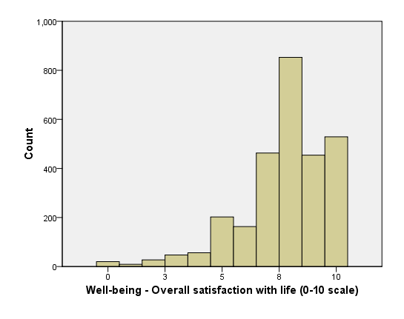

**HISTOGRAM OF WBSATLIFE**

B. TABLE OF DESCRIPTIVE DATA

|  |  |  |  |  |  |
| --- | --- | --- | --- | --- | --- |
|  |  |  |  |  |  |
| **Well-being - Overall satisfaction with life (0-10 scale)** |  |  |  |  |  |
|  | Frequency | Percent | Valid Percent | Cumulative Percent |  |
| Valid | 0 | 20 | 0.7 | 0.7 | 0.7 |
|  | 1 | 9 | 0.3 | 0.3 | 1.0 |
|  | 2 | 27 | 1.0 | 1.0 | 2.0 |
|  | 3 | 47 | 1.7 | 1.7 | 3.6 |
|  | 4 | 56 | 2.0 | 2.0 | 5.6 |
|  | 5 | 202 | 7.1 | 7.2 | 12.8 |
|  | 6 | 163 | 5.8 | 5.8 | 18.6 |
|  | 7 | 463 | 16.3 | 16.4 | 35.0 |
|  | 8 | 853 | 30.1 | 30.2 | 65.2 |
|  | 9 | 454 | 16.0 | 16.1 | 81.3 |
|  | 10 | 529 | 18.7 | 18.7 | 100.0 |
|  | Total | 2823 | 99.6 | 100.0 |  |

|  |
| --- |
| **Statistics** |
| Well-being - Overall satisfaction with life (0-10 scale) |
| N | Valid | | 2823 |
| Missing | | 11 |
| Mean | 7.74 |
| Median | 8.00 |
| Std. Deviation | 1.890 |
| Skewness | -1.225 |
| Std. Error of Skewness | 0.046 |
| Kurtosis | 2.078 |
| Std. Error of Kurtosis | 0.092 |

INTERPRETATION OF THE VARIABLES

A total sample of 2823 case study observed with a 0-10 scale measurement with the highest frequency of 529 and a least frequency of 9. The wbsatlife case had a mean value of 7.74, a median value of 8.00, standard deviation of 1.890, skewness of -1.225, kurtosis of 2.078 respectively.

1. CORRELATION BETWEEN WELL BEING-OVERALL SATISFACTION WITH LIFE (wbsatlife) AGE AT TIME OF INTERVIEW (age).

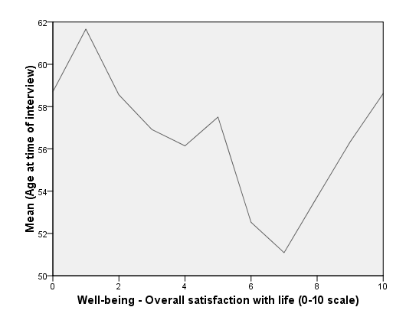

**LINE CHART OF AGE AND WBSATLIFE**

B. SUMMARY STATISTICS THAT DESCRIBE THE CORRELATION BETWEEN AGE AND WBSATLIFE

|  |
| --- |
| **Descriptive Statistics** |
|  | Mean | Std. Deviation | N |
| Age at time of interview | 55.02 | 18.613 | 2834 |
| Well-being - Overall satisfaction with life (0-10 scale) | 7.74 | 1.890 | 2823 |

C. ONE SAMPLE TEST EVALUATING AGE AND WBSATLIFE

|  |
| --- |
| **One-Sample Test** |
|  | Test Value = 0 | | | | | |
| t | Df | Sig. (2-tailed) | Mean Difference | 95% Confidence Interval of the Difference | |
| Lower | Upper |
| Age at time of interview | 157.362 | 2833 | 0.000 | 55.020 | 54.33 | 55.71 |
| Well-being - Overall satisfaction with life (0-10 scale) | 217.665 | 2822 | 0.000 | 7.742 | 7.67 | 7.81 |

(p<0.05) statistically significant

EXPLANATION OF CHOSEN STATISTICAL TEST

The samples come from an approximately normal distribution hence the use of one sample test.

INTERPRETATION

The relationship between age and well being-overall satisfaction with life(wbsatlife) is the test results been statistically significant (null hypothesis been true).

1. APPROPRIATE CHART OF HW OVERALL SATISFACTION WITH LIFE DIFFERS ACCORDING TO WHETHER SOMEONE IS IN PAID WORK.

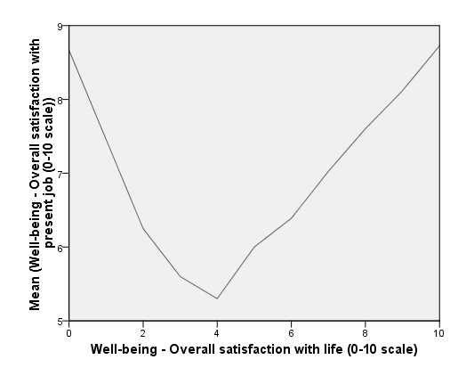

**LINE CHART OF WBSATLIFE AND WKING**

B. TABLE OF SUMMARY STATISTICS THAT DESCRIBE HOW OVERALL SATISFACTION WITH LIFE DIFFERS ACCORDING TO WHETHER SOMEONE IS IN PAID WORK.

|  |
| --- |
| **Descriptive Statistics** |
|  | Mean | Std. Deviation | N |
| Well-being - Overall satisfaction with life (0-10 scale) | 7.74 | 1.890 | 2823 |
| Well-being - Overall satisfaction with present job (0-10 scale) | 7.58 | 2.075 | 1260 |

C. STATISTICAL TEST EVALUATING THE DIFFERENCE OBSERVED

|  |
| --- |
| **One-Sample Test** |
|  | Test Value = 0 | | | | | |
| t | Df | Sig. (2-tailed) | Mean Difference | 95% Confidence Interval of the Difference | |
| Lower | Upper |
| Well-being - Overall satisfaction with life (0-10 scale) | 217.665 | 2822 | 0.000 | 7.742 | 7.67 | 7.81 |
| Well-being - Overall satisfaction with present job (0-10 scale) | 129.646 | 1259 | 0.000 | 7.580 | 7.47 | 7.69 |

(P<0.05) statistically significant

EXPLANATION OF CHOSEN STATISTICAL TEST

The samples come from an approximately normal distribution hence the use of one sample test.

INTERPRETATION

The link between well being-overall satisfaction with life(wbsatlife) and whether someone is in paid work(wking) is the test results been statistically significant (null hypothesis been true).

1. OVERALL CONCLUSION

In question 1, A total sample of 2834 case study observed with a 0-10 scale measurement with the highest frequency of 529 and a least frequency of 1. The wbsatlife case had a mean value of 7.74, a median value of 8.00, standard deviation of 1.890, skewness of -1.225, kurtosis of 2.078 respectively.

In question 2, The relationship between age and well being-overall satisfaction with life(wbsatlife) is the test results been statistically significant (null hypothesis been true).

In question 3, The link between well being-overall satisfaction with life(wbsatlife) and whether someone is in paid work(wking) is the test results been statistically significant (null hypothesis been true).

IMPLICATION OF FINDINGS

The analysis carried out indicated that the result from the data generated by testing or experimentation is likely to be attributable to a specific cause. It indicated that the the observed relationship/link is unlikely to be due to chance.

These findings relate to other literature in terms of housing and related topics, local authority services, health services, healthy behaviors, material deprivation.

Explanatory factors/variables to be considered include gender, ethnicity, economic status, hours usually worked in a main job, education, well being-overall satisfaction with present job, number of healthy lifestyle behavior, material deprivation, local authority and local health board.

Further analysis to be conducted should be the relationship/link/difference in well being (wbsatlife), (wking),age, gender, ethnicity, economic status, hours usually worked in a main job, education, overall satisfaction with present job, number of healthy lifestyle behavior.

REFERENCE

Llwodraeth cymru welsh government,2018; National survey for wales, Wales. Accesed:http://www.nationalarchives.gov.uk/doc/open-government-licence/version/3/